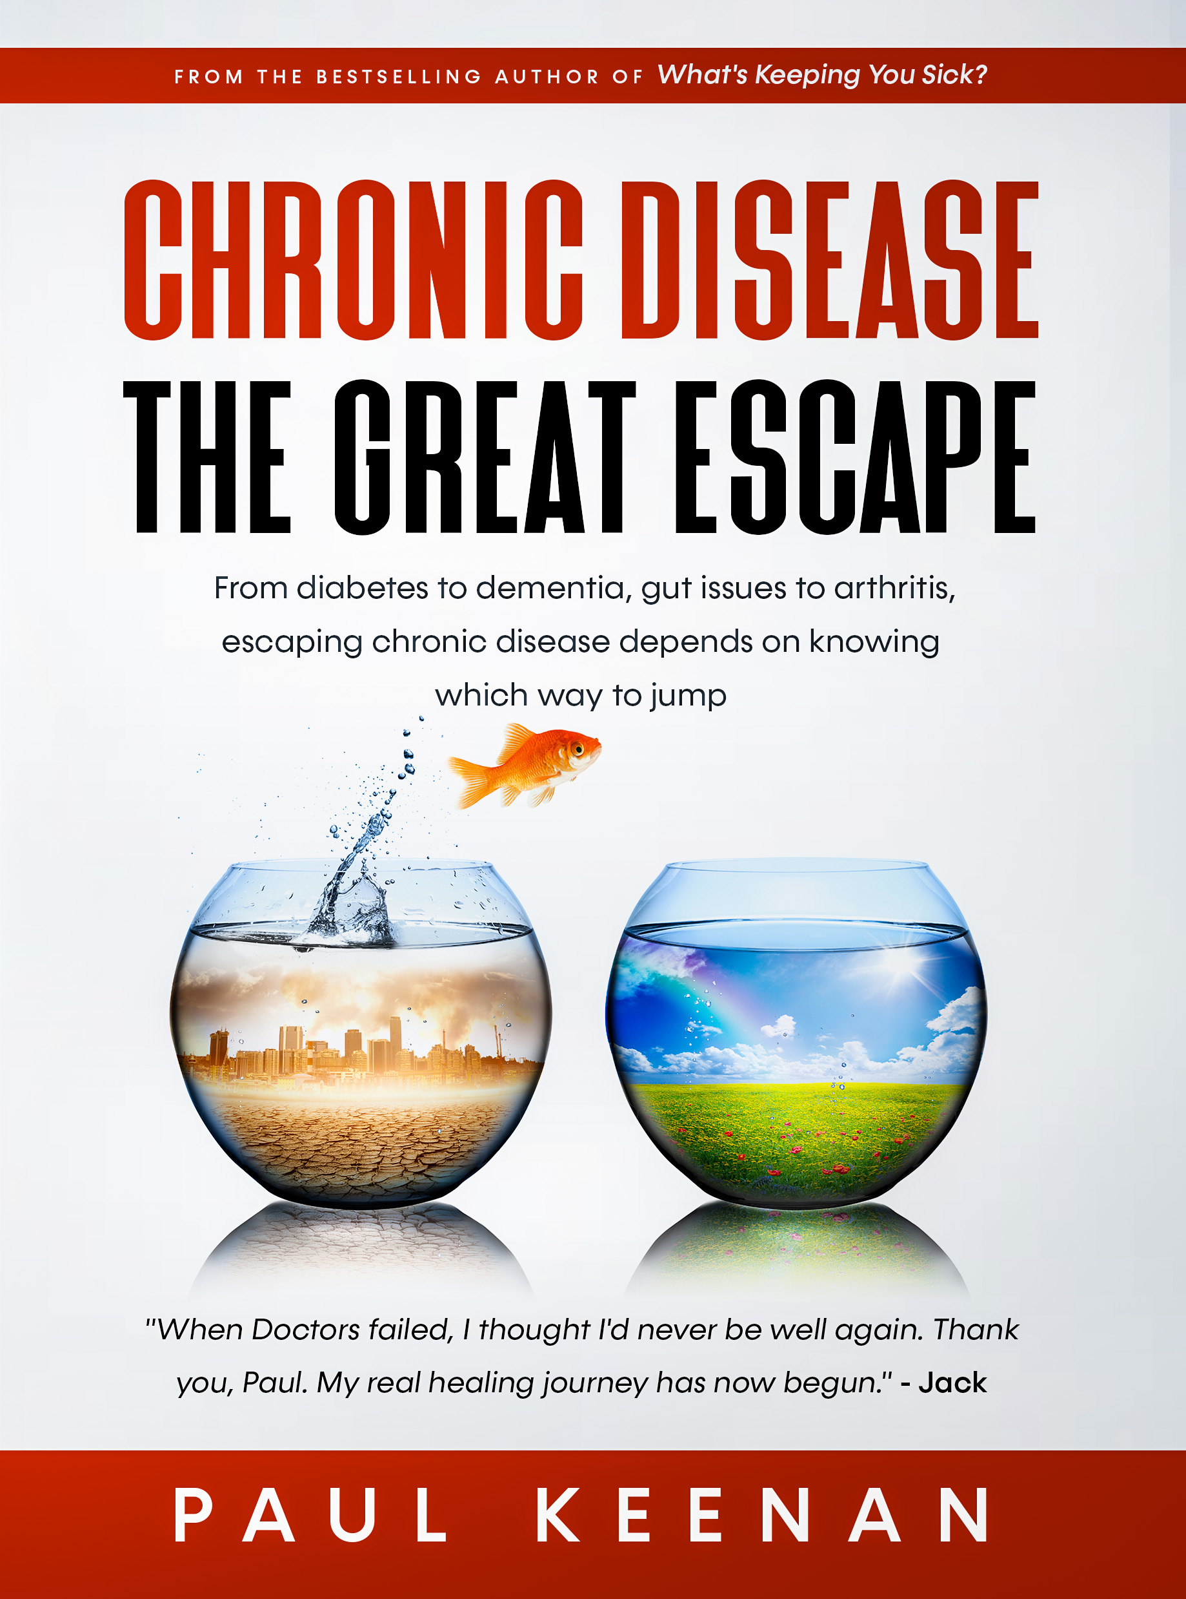

Chronic Disease
The Great Escape

By

Paul Keenan

Copyright ©2022 Paul Keenan
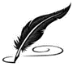
This e-book is protected by copyright law. All rights are reserved. No part of this publication may be reproduced, stored in a retrieval system, or transmitted in any form or by any means, electronic, mechanical, photocopying, recording, scanning, or otherwise, without the prior written permission of the copyright owner.
The trademarks, logos, and service marks (collectively the “Trademarks”) displayed in this e-book are registered and unregistered Trademarks of the copyright owner. Nothing contained on this e-book should be construed as granting, by implication, estoppel, or otherwise, any license or right to use any Trademark without the written permission of the copyright owner.
Unauthorized use of this e-book, including but not limited to, the reproduction, distribution, display or transmission of the content of this e-book, is strictly prohibited.
Because of the dynamic nature of the Internet, links and QR codes may stop working.

Reviews
“You always share such wonderful knowledge. It can only come from a person who has attained wisdom through experience and has learned so many aspects of healing from around the world. Thank you for that.”
Jena Davis, US

“Outstanding wealth of information (crazy statistics! I was blown away) written in an easy understandable way – great book to get you on your way to well-ville. I cannot recommend enough and I am a VERY skeptical person when it comes to health guru stuff!!!”
Anonymous

“I encourage anyone interested in Natural healing and even those that are maybe not too sure, to read this book…it’s an eye opener and possible life changer when it comes to how you treat your body.”
Susan Boons, UK

“…just to say a big thank you Paul, you changed my life”
Paula Valderra, Dubai

“In my search for better health I found this book. Not only did I find a person who I can agree with concerning our medical system, I found resources to further my research… good examples and resources clear through. Thanks for the down to earth advice”
Sandy Zabel

“I applaud you. It’s a gem!”
Pat O’Keefe, SA
Important Notices
The information in this book is presented for the educational and free exchange of ideas and speech in relation to health and wellness only. It is not intended to diagnose any physical or mental condition or to prescribe or promote any particular product(s). It is not intended as a substitute for the advice and treatment of a licensed professional.

In the event you use any information within the book for your own health, you are prescribing for yourself, which is your constitutional right and for which the author of this book assumes no responsibility.

Additional Info
Chronic Disease The Great Escape is a revised and updated version of Fire Your Doctor Choose Life.

Chronic Disease The Great Escape is an ideal Companion Book to the What's Keeping You Sick? series. The latter highlights the many ways which block healing. The former, what supports it.

Within this book, certain words may be misspelt. Use of these words is not illegal. Unfortunately, some parties are suppressing information which doesn’t fit a particular narrative.

I appreciate some find it difficult to work from a book and prefer the personal touch. If this is you, feel free to reach out to me, directly, via email or Messenger.

Links and QR Codes to more help, are at the back of the book.

Foreword

What can we do in an Age where chronic disease is at frightening levels and medical doctors will not, or cannot, help? When their interventions make us worse not better? When Alternative Therapies aren’t working, either?
When years of modern medicine proved ineffective, in resolving chronic physical and psychological disorders, Paul Keenan turned to Alternative Therapies. Over two decades there was hardly a therapy he did not try. Frustrated by the failure of both modern medicine and alternative therapies to heal him and close to breakdown, Paul was left with no choice. He fired his Doctors, fleeing abroad, in a desperate attempt to save his sanity and his health.
When, in an Indian backwater, a traditional Ayurvedic healer reversed his arthritis, Paul’s eyes were opened to the power of natural healing. Inspired by this experience, Paul spent the following years learning the methods of the Great Healing Masters, in order that he could fulfil a promise he made, to help others.
Chronic Disease The Great Escape presents, in non-scientific language, important research, hidden knowledge and practical methods of healing. Wrapped in buckets of common sense and a touch of British wry humour.

Dedication

This book is dedicated to my children, who I hope will be wise enough to refer to it, in time of need. And to YOU, the courageous individual, seeking to reverse chronic disease, who knows, instinctively, Nature holds the key.
Acknowledgments

I acknowledge the Champions of the last century who fought to bring important healing knowledge to the world.

Dr John Christopher; Dr Max Gerson and his daughter Charlotte; Dr Richard Schulze; Linus Pauling; Dr Abram Hoffer; Gandhi, who established ‘Nature Cure’ Centres throughout India. The humble, Traditional Ayurvedic healers I encountered who, with compassion, devotion and skill, showed me a better way.
Who Should Buy This Book?

Everyone.

At the rates of sickness we are seeing, you are virtually guaranteed to succumb to one or more chronic, degenerative disorders, by the time you are 50.

Cancer
Heart Disease
Diabetes
Arthritis
Obesity
Anxiety, Depression, Bipolar, ADHD, Addiction
Lyme Disease
Parasites
Fibromyalgia
Hypertension
Allergies
Alzheimer’s
Asthma
Chronic Fatigue Syndrome
AIDS
Gastrointestinal Diseases – Crohn’s, Colitis, Diverticulitis, IBS
Metabolic Disorder
Autoimmune Disorders – MS, Celiac Disease, RA, Thyroiditis

Many others.
“You know you suffered many years with physical and psychological disorders?” prodded the Naturopath.
“Yes”, I responded.
“And you know you travelled the world looking for cures?”
“Uh-huh”, I replied, wondering where this was heading.
“I could have healed you in 3 days”.
TABLE OF CONTENTS

Introduction 1
Chapter 1 The Health You Deserve 6
Chapter 2 Approach with Care 16
Chapter 3 Open Your Mind 21
Chapter 4 “Why Am I Sick, Doc?” 25
How Bad is It? 30
Suppressing Symptoms CAUSES Disease 31
Chapter 5 The Diagnostic Dance 33
Christa 39
Chapter 6 Rise of the Health Coach 40
Chapter 7 Nobody Heals You 48
100 Doctors 50
Greg 56
Stewart 57
Chapter 8 Nutrition and Healing 59
Chapter 9 There Is No Food in a Supermarket 62
Chapter 10 What is Real Food? 81
Chapter 11 Finding the Right Diet 82
Jennifer Brents 92
Chapter 12 The Six Tastes 97
Chapter 13 The Five Layers of Healing 104
The Geordie ‘Guru’ 106
The Gluttonous Priest 107
The Spiritual Seeker 108
Angela 110
Chapter 14 Breaking the Chains 113
Craig 115
Chapter 15 Modern vs Alternative 117
Chapter 16 It is Not Your Fault 128
Chapter 17 Render Unto Caesar 130
Sarah 136
Chapter 18 Nature’s Laws 137
Chapter 19 Curing a ‘Great Great’ 141
Chapter 20 A White Coat Has Magical Powers 142
Chapter 21 Crying Out For Change 146
Chapter 22 Health Freedom 147
Chapter 23 Big Pharma 156
Chapter 24 What's Keeping You Sick? 162
Why Supplements Don’t Work 164
Stewart’s Bypass 170
Chapter 25 Useful Techniques 172
Peace of Mind 176
Chapter 26 Do You Want to Heal? 179
Chapter 27 The Power of Belief 180
Chapter 28 “Drain The Swamp!” 182
Borax 184
Kerosene and Turpentine 190
Chapter 29 Solutions 195
7 Elements of a Healing Plan 199
Water 205
Frank Tippett 207
A Most Unexpected Option 208
Reversing Diabetes 212
Carlos Cervantes 214
Lyme Disease 215
30 Days to Health 223
Chapter 30 Psychiatry – A Dark Art 238
Stress-Related Disorders 243
Chapter 31 Who Am I? 251
Chapter 32 Wisdom of the Ancients 263
Chapter 33 Support is Critical 266
“Mum Doesn’t Look so Good” 268
Peter Seeks the Easy Way 271
Chapter 34 “You Cannot Heal a Dirty Body” 272
Chapter 35 Look in the Mirror 276
“It’s Only Two a Day!” 278
Chapter 36 What You Have Learned? 279
The Next Step 281
Appendix 282
Sources 285
How You Can Help 287
Additional Resources 288
Special Offer - Chronic Disease SET 289
FREE Healing Blocks Checklist 291
Chronic Disease The Great Escape 292
Healing Retreats 293
About The Author 294

DAN

84 year old Canadian, Dan, was a gentle giant. When he came shuffling, up my drive, he couldn’t bend his fingers they were so swollen with Rheumatoid Arthritis.
Dan was 40kg overweight and understandably down in the dumps. A big meat-eater all his life he told me about his triple heart-bypass, cancer and how the medications he was taking only made his Arthritis worse. Dan had certainly experienced his share of illness.
“I am too old”, he said. “The Doctors have written me off”.
Alternative practitioners refused to help Dan as he was considered high risk. They do not have the protection of the State and could go to jail, if Dan dropped dead on their doorstep. I explained, for the same reasons, I could not help.
“Please”, said Dan. “Nobody else will help me”.
My heart went out to this dignified man, so I recommended a simple protocol with a good track record of safety and success. Dan came off most of his medications and commenced a citrus-based, juice Fast. Like most, he could not imagine going two hours without eating but nevertheless committed to the program.
After 7 days, Dan was feeling so well he asked to do 3 more. After 10, he called again and said he was feeling even better and didn’t want to stop. I suggested he do so at 14. He was, after all, 84.
On the morning of the 15th day, Dan walked up my drive, transformed. He had lost 10kg, looked ten years younger, his arthritis symptoms were gone and depression had lifted. It was wonderful to see.
“How did you get on with the juices?” I asked.
“It was easy after the first day”, said Dan. “I wish I could have kept going”.

“You may choose to look the other way, but you can never say again that you did not know.” - William Wilberforce

Introduction
“You’re FIRED!”
More of us should try it, don’t you think? Walk into our Doctor’s office, look them in the eye and give it to them straight.
If you think about it, the idea you would buy a book which promotes Alternative Therapies, over conventional medicine, is an act of independence and defiance some consider revolutionary. I am sure you were not thinking that when you picked this off the bookshelf or ordered it, online. You just want to know how to fix your Arthritis or Cancer or Diabetes or Allergies.
Welcome to the ‘Bypass Age’. An Age, where, if Doctors cannot, or will not, heal you, you bypass them. An Age where, if drug companies, Medical Associations, ‘captured’ Consumer Protection Agencies and ‘revolving-door’ government flunkies, erect barriers to change, you bypass them, too. Over 50% of patients are using Complementary and Alternative Medicine (CAM), bypassing their Doctors.
A revolution in Health Care is certainly needed. We are the sickest species on the planet and getting sicker. Mankind cannot sustain this expensive, techno-chemical assault on our bodies, minds and environment for much longer. The number of us succumbing to chronic, degenerative disorders is too great. Perhaps, it will come when 1 in 2 of our children are Autistic (as projected). Perhaps, when more than half die from Cancer (we are nearly there, now). When Corporations make more money CURING disease than TREATING it. Or, as a Doctor friend bluntly put it,
“When the owners and CEOs of ‘Big Food’ and ‘Big Pharma’ are all swinging from the same branch.”
It is coming. I hear it with every phone call and every Retreat guest I see. They may use different words but the message is the same.
“I’m sick and my Doctor cannot heal me.”
An explosion of interest in Natural and Alternative methods of healing has occurred and you and I are part of it. Quite when we reach tipping point, where wholesale change will come, is hard to say. It isn’t just Health Care that needs to change. Doctors are those we see AFTER we have fallen ill. What is making us sick BEFORE we see the Doctor also needs to change. The choices you and I make, each day, consciously, or unconsciously, which build health or disease. Think about that. Every choice you make is building health or disease. Are you fully conscious of this? Or is your health ‘The Doctor’s job’ and you don’t think about it?
You may not realize but you are part of a massive shift in human awareness. For the first time in history, we have access to knowledge the rich and powerful traditionally held. Instant access to more information, in one hour on the internet, than we had in a lifetime, 100 years ago. It is a wonderful window of opportunity which, unfortunately, is closing. With every keystroke and mouse movement tracked and archived and internet giants increasing their filtering of what we are allowed to see. For example, with vacsenes (deliberate misspelling). Internet titans have clearly decided we are not allowed an honest debate about the damage they cause.
When my mother died a painful and undignified death, there was no internet and no hope. You accepted what Doctors told you, without question, because ‘The Doctor knows best’. Now we understand this is not true. Doctors know only what they have been taught. They treat, only in a way they are allowed to treat. They know nothing about alternatives, pay lip-service to prevention and granny knows more about nutrition than they do. Today, thanks to the internet, within minutes of your Doctor declaring your condition ‘incurable’, putting you on a lifetime regime of colourful pills (while, sniffily, extinguishing hope anything else can heal you), you can be online, discovering simple, safe, healing methods you never knew existed. Whether they work or not I will come to. But at least you know of their existence.
When I first started researching Rheumatoid Arthritis (RA), the disease that killed my mother, my knowledge of medicine and the health system was non-existent. I was strong (apart from seasonal hay fever) and didn’t think about health at all. You don’t, when young. Sickness is something that happens to others. Then, after my mother passed away, I came across an article explaining RA responds well to diet. This was the first time I had heard this. I investigated further. At first, curious, then appalled, finally angry, when I discovered Rheumatoid Arthritis is curable without NSAIDs, Methotrexate, steroids and gold injections and my mother need not have suffered the terrible end she did. I wanted to know why Doctors did not know about this, when it was in their own literature? Why dietary therapies were not applied to RA sufferers, in hospitals? Why Doctors did not know about natural methods of healing. Juice and water fasts, raw food diets, hydrotherapy and so on? During Retreats, I see RA symptoms resolve, within days, just through dietary change. Ask Dan.
Then I discovered a world I had no idea existed. A world where Doctors are not allowed to suggest Alternatives, or deviate from ‘Standard Practice’, otherwise they can be struck off. A frightening dystopian world where parents of children with cancer can be jailed, or lose their children to the State, if they don’t submit them to the violent assault that is chemotherapy, radiation and surgery. Even when their odds of survival, from such treatments, are known to be zero. A world where the State can kidnap your children for not allowing them to be vacsenated, though they may be healthier than other children, under the invented and false pretext of ‘herd immunity’. A world gone mad, where what was once normal and natural (natural immunity) is now labelled ‘child abuse’. Where pharmaceutical ‘Robber Barons’ control medicine, for profit. Not Doctors, for health.
I started to dig a little deeper and learned how the health system really works, as opposed to how I thought it worked. How it is a business, run by businessmen, and as long as treatments make more money than cures, we will have treatments and no cures. Doctors fight valiantly to save lives… I might have died on two occasions without them… but for chronic and degenerative disorders, 75% of what plagues us, they can do little, only make matters worse.
I learned the system is a failure. That it has been designed to fail. Because if it succeeded, it would put itself out of business. I discovered an unofficial history of medicine, instead of the approved versions, which shed light on why there were no cures. That, when courageous healers dared to heal the sick, the health cops, on behalf of the medical robbers, would persecute them and suppress knowledge of their methods. Often waiting until the healers had made enough money for the ‘smash and grab’ to be worthwhile. In the suppressed 1953 Fitzgerald Report the Chief Investigator did not mince his words…
“Public and private funds have been thrown around like confetti at a country fair to close up and destroy clinics, hospitals and scientific research laboratories which do not conform to the viewpoint of medical associations.”
I found out how promising treatments and natural compounds would never be approved because it takes hundreds of millions of dollars, to get them through clinical trials, and natural products cannot be patented. Which means only un-natural molecules are approved, even when known to be less effective and harmful. Then I understood. This is a very exclusive Club, into which only the wealthiest corporations are granted access.
There was so much more I did not know. How our present-day health system was created by two powerful families. Why fossil-fuel-derived, pharmaceutical ‘medicine’ came to dominate and how chemistry and ‘science’ came to trump biology (you may have noticed, lately, how biology is making a comeback, with ‘Bio’ this and ‘Bio’ that).
I learned why Cancer treatments have not changed, in decades, and how cancer charities and pink ribbons are a cynical sham, fleecing the public. They must be if you think about it. The mandated conventional treatment, for over 60 years, is chemotherapy, radiation and surgery. Or else. Doctors attempting non-mandated methods can be struck off or jailed. This being the case, why are Cancer charities nagging the public constantly for donations ‘for research’? Into what? They make NO serious investigation into alternatives. Quite the opposite. Cancer charities work with medical associations, to undermine medical schools, hospitals and practitioners, even when they have ample clinical evidence and customer testimonials, showing natural methods produce better outcomes than conventional treatment. When you dig, you realize cancer research is almost always designed to fail.
You learn from people like Ben Goldacre, who wrote ‘Bad Pharma’, how rigged studies and manipulated science can be used to sell junk food pyramids, junk flu pandemics, junk remedies and undermine competition. You learn of the immense harm pharma drugs cause. The many side effects your Doctor somehow forgot to mention, when he prescribed them. Or learn from Nature, a weekly science journal, how most prescribed drugs do not work for the majority that take them. That only 2%, if that, benefit from taking Statins. Which means 98% are only getting the side effects.
You discover the top 5 drug companies earn more, per year, than the whole of Africa. That patients get better ON treatment not BECAUSE of treatment.
There was so much to take in. Once I started digging I could not stop. Each shocking new revelation, chipping away at my childlike trust and naivety regarding Health Care. Make that Sickness Care.
I learned I was an entry in a Health Corporation’s balance sheet, generating expected lifetime revenue of $1,000,000 from medication, for my ‘incurable’ disease. And if, like many patients, I’m taking three or more medicines, what a bonanza for owners and shareholders. That, in the last two years of my life, what was left of my assets (including my home) would be pounced on, to pay for cancer treatment or heart by-pass operations. A final mugging by the criminal Corporate State as I passed away. I knew it was true, knowing families who have been thrown out of their homes because a parent, or family member, could not afford medical bills or health insurance. Or, even if they could, were denied by a myriad of exclusions.
I have had a taste of medical racketeering. In an emergency visit to a private hospital, due to food poisoning, it was clear all they cared about was my ability to pay. You could argue this is reasonable. However, when they saw I was a foreigner, the fees were jacked up and suddenly I’m pressured to take all kinds of tests and procedures. To stay “just a few more days”, for ‘observation’. A euphemism for, “we haven’t emptied your bank account yet”. After 4 days, I was relieved to escape with the obligatory shopping-trolley full of over-priced meds, minus my (not-so”useless”) appendix. Thailand’s Prime Minister is promising to rein in rampant overcharging, after street protests.
All this is depressing and people don’t like to hear it but I needed to know. Because, by not knowing, I had stayed, far too long, in a system happy to keep me sick. Sometimes, I wish I had remained ignorant. It is heart-breaking to see millions suffer and die when their diseases are preventable and reversible. I have to stay positive. Whatever is happening, today, does not have to be our future. Instead of passive actors in this real-life drama, we can be revolutionaries. The vanguard of a human wave, taking back control of our health and that of our children. A wave that seeks to give medicine back its Soul. A wave saying to Medical Authorities:
“If you aren’t going to heal us, step aside, while we heal ourselves”.
Thanks to the internet I discovered my disorders were not ‘incurable’ after all. That healers existed, who had reversed cancer and heart disease, diabetes and depression, auto-immune and anxiety. Today, the same methods which reversed my arthritis, in India, can be easily found with a few mouse-clicks. I can order rain-forest herbs, nutrient-dense drinks, design my own healing program and source everything I need, online. I am in the ‘Bypass Age’ and, just as water flows around a rock, I can bypass all that has previously failed and heal myself.
The good news is, if I can do it, so can you.

Chapter 1
The Health You Deserve
“We all deserve a life of glowing health and vitality, free from pain and sickness. Whether in body, mind or spirit. It is our birthright. To be happy. To be at peace. To enjoy a long, healthy existence on this beautiful planet. To love ourselves, our families and our fellow man. To pass away peacefully in our sleep. Such a life is attainable if we live, wisely, in accordance with natural laws.”
- Paul Keenan
A host of mental and physical maladies have befallen mankind, like Biblical plagues. Diseases and disorders I never heard of, as a child, are today ‘incurable’ epidemics.
The number of conditions is staggering and getting worse. There are around 80 Auto-Immune disorders, 200 types of Arthritis, 200 different Cancers and over 300 Psychiatric disorders. In the U.S., half of men will get Cancer. 1 in 3 women. When I was young, it was 1 in 25. Coronary artery disease is the No.1 killer, yet barely existed before 1900. 1 BILLION people globally – 70% of Americans, 66% of Britons and 63% of Australians are overweight or obese. Obesity rates in Australia are climbing faster than anywhere else in the world. The cost to society, of obesity-linked disease, is staggering.
Modern medicine can be brilliant, with acute and emergency care (our Masters don’t want us dying too early). Yet, for chronic and degenerative disorders such as cancer, heart and cerebrovascular disease (stroke), which cause 75% of deaths in industrialized nations, it is a catastrophic failure. Millions are set to be tortured, scarred, mutilated, poisoned and burned, by well-meaning but ignorant medical doctors, attempting to relieve suffering, until they are finally rejected and sent home to die. Think I am exaggerating?
In 2013, the National Cancer Institute admitted two important cancers, early stage breast cancer and prostate cancer, were NOT cancers after all but harmless lesions. Over a 30 year period, 1.3 million women were subjected to a combination of mastectomy, lumpectomy, radiation and chemotherapy. Many more had breasts irradiated and were filled with fear and dread. Who knows how many new cancers this created. The same applies to men diagnosed with a form of prostate cancer. Other cancers were identified, too.
“…many lesions detected during breast, prostate, thyroid, lung and other cancer screenings should not be called cancer at all but should instead be reclassified as IDLE conditions, which stands for “indolent lesions of epithelial origin.”
“…hundreds of thousands of men and women are undergoing needless and sometimes disfiguring and harmful treatments for pre-malignant and cancerous lesions that are so slow growing they are unlikely to ever cause harm”
Such horrific error (I’ll give them the benefit of the doubt) would never occur with non-toxic, non-invasive alternatives. In the U.S., Dr Dean Ornish has proven his program to reverse heart disease, using diet, stress reduction and exercise, works. Patients can be out of danger within a month. Yet, a friend who recently underwent triple-bypass surgery, believing he was getting ‘brand new plumbing’, is carrying livid scars on his leg and chest and has to spend a year recovering. He had never heard of Dean Ornish or his program, nor had his Doctor suggested it.
If someone asked if I prefer a month on a healing diet or a surgeon to saw open my chest, rip out a vein from my leg, plunge a knife into my heart, with the possibility I might die on the operating table, I think I might take a crack at the diet. In what way is undergoing major surgery better than a year eating healthy food, exercising and reducing stress, which will put me out of danger, restore ALL of my circulatory system, resolve other disorders I may have and renew my love of life?
My mother spent her last two years suffering what I can only describe as medieval medical cruelty, due to chronic Rheumatoid Arthritis. The Doctors were conscientious and heroic but limited to pain management, which devastated her body more than the disease. What made it worse is they knew. Appalled at her suffering, I asked if there was anything else the family could try? The Doctors said “No”. After one-too-many trips to intensive care, she was put out of her misery, with an overdose of morphine.
Where is the healing? Where is the effort to reverse disease? We believe we have a Health system not a Disease Management system. When you only manage a disease and make no attempt to address its underlying cause, are you even a Doctor? Medical Doctors have abdicated their responsibility to heal but they can only work within the boundaries set for them. Using the tools and medical education they are provided with. If a Doctor’s education is narrow and limited, so will be his practice. It does not matter how brilliant they are (and many Doctors ARE brilliant), doctors are incentivized, by carrot or stick, to treat and not heal. They are trained to arrogantly dismiss alternatives, not investigate and embrace them. Doctors excel at managing symptoms but are ignorant of how to heal. Sadly, it is the nature of ignorance the ignorant are unaware they are ignorant.
I’m old enough to remember when they used to give medicine for temporary relief. In the space of a decade, whole populations are now taking them, for LIFE. Who benefits? The Doctor is happy. He is kept employed and rewarded. Health Corporations are happy, their owners reap stupendous profits. More so when diseases progress to Cancer, heart disease and severe disability. (Patients pay more when they think they are going to die).
How about you? Are you happy financing your Doctor’s BMW, while you struggle to afford a wheelchair? Are you happy taking toxic, synthetic chemicals, that fix one problem and create two more, for the rest of your days? Pills which never heal, only prevent you taking steps to heal yourself. Let’s not beat about the bush. Unless you address its underlying cause, your disease WILL progress.
Doctors tell you to improve your diet, yet know nothing of nutrition. Millions are getting sick and fat, following government Food Pyramid guidelines, heavily influenced by the meat and dairy industry. Despite their infatuation with science, Doctors do not know how the body works. If they did, they would not be dying from the same diseases we get. If Doctors knew how to prevent Cancer, they would not get Cancer and if they did, would be able to reverse it, in themselves. But they do and they can’t. So why would anyone with Cancer, seeking to heal, see a conventional Doctor? With ANY chronic disease for that matter?
Patients, frustrated with Doctors’ failure, are increasingly looking elsewhere, turning toward CAM (Complementary or Alternative Methods). Some Doctors, too. The coming together of conventional and alternative systems is known as Integrative Medicine. Functional Medicine is another promising development. 40% of patients in the U.S. are enjoying safe, non-toxic, non-invasive treatments which support the body, not burden it. Examples are Acupuncture, Homeopathy, Osteopathy, Chiropractic and Herbalism. These systems can be very helpful. Unfortunately, they aren’t being applied, correctly (I explain why, later). So rarely reverse chronic, degenerative disorders.
In Germany, German Biological Medicine has grown out of Doctors’ greater freedom to innovate. This highly complex system draws on different systems of healing: - ancient, modern and alternative. There is no attachment to one particular modality and practitioners are not forced to stay within rigidly imposed boundaries. This approach makes perfect sense and how I reversed my own disorders.
What about pills? A multi-billion dollar, over-the-counter (OTC) supplements industry has grown up, to meet consumer demand for instant fixes, which are mostly useless, if not fraudulent. As a result, we end up returning to our Doctors, still sick, poorer in pocket, with a cynical view of alternatives.
Then there is the most important factor of why we get sick and how we recover. We all make excuses but let’s face it. The reasons we are sick are the choices we make, each and every day.
Each time we consume junk food, sweet biscuits, fancy coffees or sweetened sodas, we create imbalance, acidity, a nutritional deficit and disease, within our bodies. Each time we fail to exercise, we create stagnation, putrefaction and toxic accumulation. Each time we are rude, negative, angry, fearful, deceitful, lacking in love, compassion and consideration for ourselves and our fellow man, we are creating conditions for psychological and physical disease to take hold and... dare I suggest... in this godless age... Spiritual death.
Given a choice between fresh fruit and a sticky bun, we turn our noses up at the fruit and opt for the bun. The fruit is building health (“an apple a day…”) while the bun is building disease. We choose disease, even when we know the fruit builds health. For any biological species this is insanity. We are committing suicide with our forks and do not seem to know or care. Not only are we killing ourselves but also our children. Guaranteeing, in them, the same chronic diseases we suffer. Remember when they called it adult-onset diabetes? No more. Now babies are born with diabetes. Sadly, too many parents are psychologically divorced from behaviours which harm their children.
What about Mental Health? The numbers are staggering. 25% of Americans have some kind of mental disorder. 1 in 4 of the population. There is reason to doubt many diagnoses but how many are due to a deficiency of Zoloft, Prozac, Xanax or Ativan? Zero. 6 million children in America (and increasingly in the UK), who should be outside, climbing trees, are forced to sit in grey, concrete, confinement centres, known as schools, to be drilled and indoctrinated (mostly, in utter nonsense). When they show signs of boredom and restlessness, they are given Ritalin (methylphenidate), classified by the Drug Enforcement Administration as a Schedule II narcotic. The same classification as cocaine, morphine and amphetamines. So much for the ‘War on Drugs’.
Most of these children are raised in poverty, their bodies and minds poisoned by toxic metals, chemical sugars and subversive messages to ‘do what you want’. Have you watched children’s cartoons? Characters, like ‘Spongebob Squarepants’, plant bad behaviour and ‘attitude’ in the minds of the young. Messages to defy parents. To demand what is toxic for them. Every cartoon filled with burgers, hot dogs, sodas and ice-cream. The brainwashing is not even subtle. It’s the same with infant educational material.
The effect on developing minds and nervous systems of this toxic assault, is devastating. An assault which has been going on for decades. Sick, addicted parents are spawning sick, addicted children. Caring parents are cynically undermined by a corporate mass media, instilling ‘needs’ in the young, for profit. Their health be damned. Humanity is being flushed down the evolutionary toilet. We are the most diseased generation in history. On a scale which is, clearly, by design.
In every aspect of our lives there is a pernicious agenda at work. Garbage in, garbage out. Create the problem then offer the solution. Which do not work and, on closer examination, are crafted to do even more damage.
Do you really think President Obama’s much-vaunted ‘Personalized Medicine’ initiative is going to heal anyone? Genetics is only one facet of who we are. Perhaps 1% in significance. Genetics gives us the blueprint for building a body but who is the project manager? Who gives it life? Who or what decides whether a gene is turned on or off? What does genetics have to do with someone who cannot afford to eat healthy food, purchasing nuggets, sodas and fries? What does the science of genetics have to do with how we think or what we believe? The decision whether to exercise or flop on the sofa, to be violent or peaceful? Half of America has diabetes, 75% are obese and we focus on genes, instead of locking up the vulture capitalists who have brought this metabolic disaster about.
What kind of sick civilization allows the poisoning of hundreds of millions, so a handful of parasitic overlords can enjoy obscene wealth and rule over us? Why isn’t the money spent on genetics, conquest, and bailing out corrupt bankers, being used to ensure uncontaminated soil, healthy food and decent housing? How much would it cost to take the millions of acres, set aside for cattle and plant Superfoods? Genetics is going to make already-wealthy owners even richer and you can be sure who will be paying the price. You and I. Criminal, corporate America is showing the rest of the world what lies in store for them. I dread to think about the health of future generations.
Do not misunderstand. There are solutions out there. I am going to tell you about them. There are healers out there. I have encountered them. Compassionate men and women who have taken patients... sent home by hospitals to die... and healed them, with safe, natural methods. The word ‘incurable’, not in their vocabulary. Dr Max Gerson and his inspirational daughter, Charlotte, have been healing Cancer, heart disease and other serious conditions, since the 1930s. Dr Gerson reversed Nobel Prize winner Albert Schweitzer’s Type II Diabetes and his wife’s tuberculosis, at a time when TB was taking thousands of lives and considered incurable. Schweitzer said of Max Gerson…
“…I see in him one of the most eminent geniuses in the history of medicine.”
Praise indeed. Yet why had I never heard of him and why was I not taught about him in school and why are Doctors not offering the same solution Albert Schweitzer received? When you read Max Gerson’s Wikipedia page, as people researching will, it is so damning you want to lock him up and throw away the key. The message is clear. The man is a ‘charlatan’, his methods ‘quackery’ and just in case you were thinking of giving his ‘unproven’ ideas a go, doing so might kill you. One might wonder, if Dr Gerson was curing tuberculosis and cancers when other Doctors couldn’t, who exactly the ‘quacks’ are?
‘Hit-pieces’ such as this are standard fare on mainstream sites, who condemn the speck in an Alternative’s eye, while ignoring the plank in their own. When you have seen enough of them, it becomes easy to recognize the tactics used, to keep us away from competition. Sadly, too many, including Doctors, believe what they read.
25 years ago I won a national Information Technology award. Next to the birth of my children it was my proudest moment. Head-hunters called, offering lucrative positions. My financial future was secure. I turned them down. Partly out of loyalty to my employer but mostly because I was completely ‘burnt-out’. Taking anti-depressants just to be able to sleep.
This is something I rarely see talked about. The effects of chronic illness on families. On relationships and budgets. On carers and careers. I have just come off the phone to a young lady whose father is in intensive care, with severe health problems and no insurance. The family have already expended their life savings, on medical bills, and are going deep into debt to keep him alive. With each day, the debts mount. This, when the daughter has just undergone a double mastectomy for breast cancer. My heart goes out to her and her family. The effects of sudden and serious illness can be catastrophic.
I wish my mother had known about Dr Max Gerson. I wish my father, who died at 54, from diabetes-related heart failure, had known about Dr Dean Ornish. I wish I had known of Linus Pauling and Dr Abram Hoffer who, 50 years ago, were using nutrition to resolve psychiatric and physical disorders. I wish I had discovered, earlier, the fascinating, traditional Ayurvedic healer who, in a small clinic in an Indian backwater, reversed my arthritis. Most of all I wish OUR doctors knew how to heal. It would have saved me years of physical and mental torment, the breakup of my family and the end of my career.
Someone I do know about is Dr Richard Schulze, Naturopath and Master Herbalist. Richard secretly healed patients, for twenty years, before he was forced to stop practicing. He believes absolutely… “THERE ARE NO INCURABLE DISEASES”. This colossus of natural healing would see patients four months after they were given only two months to live… the worst of the worst… and cure them. His ‘Save Your Life’ video series is a veritable treasure chest of natural healing techniques. Not everyone cares for Richard’s outspoken honesty and ‘radical’ methods but there is no doubting his ability to heal, his vast experience and his power to motivate. He would be the first person I would ask for, if seriously ill.
A less controversial colossus is Linus Pauling, winner of two Nobel’s and one of the founders of Orthomolecular Medicine. Wiki says of Dr Pauling…
‘…one of the most influential chemists in history and ranks among the most important scientists of the 20th century.’
Praise indeed. Linus Pauling surely knows what he is talking about. So I bring up the Wiki page on Orthomolecular Medicine. What does it say?
‘…a form of food faddism and even quackery.’
‘…untested’
Rounding off the mugging,
‘…some vitamins have been linked to increased risk of cancer and death.’
Goodness. Who would try high-dose vitamin therapy after reading that? But hold on a moment. Read that last sentence carefully. It is clever and misleading. What does ‘linked’ mean, exactly, and who linked it? Did they use natural, whole vitamins? Most high street vitamins are synthetic, inorganic fractions of vitamins. Notice they don’t say exactly which vitamins, so you will likely avoid them all. ‘Increased risk’ is not quantified. Is that minor risk or major?
Let’s try a little linking, ourselves. Imagine someone is killed by a truck. The driver had fallen asleep at the wheel. It might be reported like this…
‘Truck driver, asleep at the wheel, kills innocent pedestrian!’
Now let’s link the accident to something we wish to undermine…
‘Truck driver, who fell asleep at the wheel, killing an innocent pedestrian, had been taking Vitamin C!’
The implication, clearly, is the accident was somehow related to Vitamin C. How much greater would be the emotional impact if he had killed a bus full of handicapped schoolchildren? What would happen if every media outlet questioned the use of Vitamin C and fabricated even more harrowing stories? Perhaps using paid or ‘crisis actors’ (look them up), holding placards in the TV network’s car park, tearfully demanding “killer” Vitamin C be banned?
The corporate-owned media constantly manipulate emotions, to drive home desired messages. You may recall the huge media fuss about ‘stranded’ Polar Bears, linked to global warming. They failed to mention Polar Bears are excellent swimmers and were doing rather well at the time. Their numbers were increasing.
Let’s try again, this time turning the tables on the corporations. Most store-bought Vitamin C is derived from genetically-modified corn. To cast doubt upon genetic modification, let’s report, as follows…
‘GM corn linked to truck road death!’
See how easy it is? You can link to anything you wish to target. Be it a Doctor who has broken ranks, an Alternative practitioner, medical practice or beneficial product.
In my opinion, Linus Pauling, Max and Charlotte Gerson, Richard Schulze, Dean Ornish and others like them, are heroes. Meriting the highest accolades and widest possible exposure, for their contributions to healing. Instead, they remain largely unknown, their methods given little or no official acknowledgment, unless to undermine or misrepresent practitioner or therapy. It is almost impossible to find such healers in western industrialized nations. They operate in secret, or abroad, because they are not allowed to practice at home. They can teach, sell books and supplements. The few courageous souls, allowed to practice, do so, only when modern medicine has abandoned a patient. This is medical dictatorship. There is no health freedom when only a medical doctor can use the words ‘cure’, ‘treat’ or ‘prescribe’.
When I fired my doctor and travelled to other countries, seeking solutions for my own disorders, so impressed was I by the healers I met and so astounded by the simplicity of their methods, I decided to learn how they did it, so I could help others. Now, because there is such great need in society, I try to add my voice to those, who have gone before, and share my knowledge with you. You need to know what you are doing wrong, so you can put it right. You need to learn to be your own doctor because YOU are the one who makes all the choices. Nobody else. If you do not learn how to take care of yourself and your loved ones… knowledge we all used to have… you are lost. We all are.
My heart goes out to those who have searched in vain for help. Who have listened to ‘expert’ opinion and abandoned hope, believing nothing can be done.
DO NOT BELIEVE THEM.
Recovering one’s health does not have to be complicated. All you need is a clear understanding of what steps to take and the will and motivation, not only to get started, but to succeed. To end all those years where you have said to yourself, day after day, week after week, month after month,
“Tomorrow. I will start tomorrow”.
Do you tell yourself, “It is too difficult”? Are you deflated by previous failure? Banish these thoughts, look in the mirror and ask yourself a simple question.
“DO I WANT TO LIVE OR DO I WANT TO DIE?”
If you want to live, the knowledge and ideas in this book can help you. If you want to die, continue on your way and may whichever God you worship bless your journey. You DO want to live, don’t you? That’s why you bought this book.

END OF PREVIEW

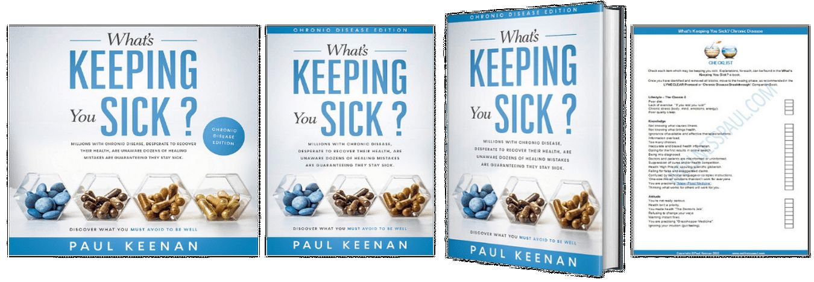
Paul Keenan Books
Select image or scan the QR Code
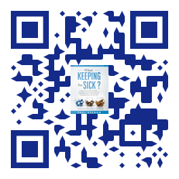

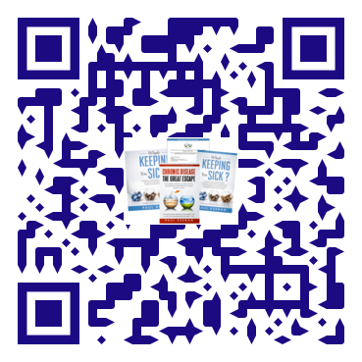
Special Offer - Chronic Disease SET
50% OFF
Audiobook, e-book, checklist and companion e-book.
$29.95 | RRP $61.80
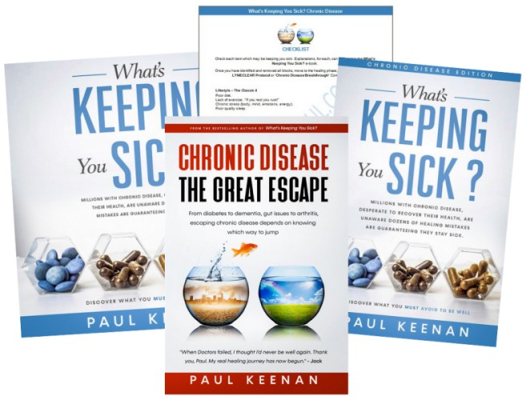

BUY NOW

